Online booking account set up
The best and quickest way to book your fitness suite slot or class at the centre is via the online booking system. If you have never used our online booking system then our team will be sending you an email before the 13th of September.
This email will come from ‘no-reply@elitelive.co.uk’ so please look out for this. The email will look as below:
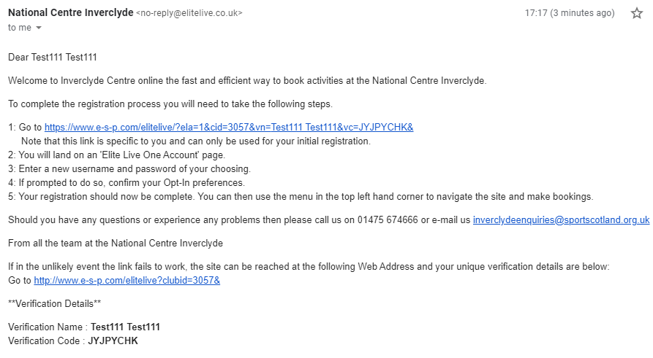
Please simply click on the link within this email to gain access and follow the steps. Please note, we are unable to retrieve your new username and password for you once you have set them up.
Once you have set up your account you can then book slots – from the 9th of September at 9am. You can book up to 7 days in advance.
Fitness suite slots will appear at the top of the booking list, please scroll down for the classes taking place on that day.
You may also book over the phone with our team who will be at the centre between 9am and 3pm from 9am on the 9th of September.

